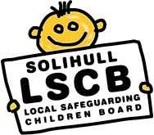
Report: Evaluation LSCB Multi-Agency Training 2018-19
Executive Summary
In the financial year 2018-19, the LSCB trained 463 delegates from a wide range of agencies. This report evaluates the effectiveness of this training programme using questionnaire data completed by training attendees.
The report finds that training evaluations continue to be overwhelmingly positive, with good evidence that LSCB/P training is not only increasing knowledge and confidence, but challenging practitioners thinking to allow them to succeed in a multi-agency environment. This is evidenced through both the quantitative and qualitative data analysed in full in the report.
However, while each module continues to be positively received, in the 2018-19 financial year 25% less delegates benefited from the training than have on average in the past. For the preceding three financial years before 18-19, total attendance at all modules has been between 600 and 650 delegates. Last year, attendance had dropped by 160 people, to 463. Further analysis showed that the LSCB/P’s Health, Education, and Early Years partners sent over 100 less staff to training than they have on average in the past. In terms of modules, Module 6 saw an exaggerated proportion of this loss in attendance – going from between 110 and 120 attendees to just 42 this year. This may be because Module 6 is a prerequisite for those wishing to attend Graded Care Profile 2(GCP2) training; 163 members of the workforce have now been trained to use GCP2 and the focus needs to move from training people to the embedding the use of the tool in practice.
Qualitative and quantitative data shows that although the training itself continues to be effective attendance is down significantly. Although some of this reduction might be explained by large commissioning/structural changes, partners must work to improve attendance. In particular they should be aware that the LSCB multi-agency safeguarding workforce development strategy introduced as a general guide that all those who regularly make child protection referrals, are regularly expected to attend child protection conferences and core groups, and/or manage or supervise those who do, should receive a minimum of 3- 6hours of multi-agency training; ideally at least 1 module per year. This is in addition to any single agency training; therefore partners need take appropriate actions to ensure this trend is reversed, as the low number of attendees ultimately means that the positive impact of multi-agency training is being felt by fewer practitioners and in turn, fewer children.

Introduction
The LSCB has trained 463 practitioners and members of staff from a wide range of organisations in last financial year from April 2018- March 2019. This report evaluates the effectiveness of this training programme using questionnaire data completed by training attendees. It is the second and final report covering the period of the ‘LSCB multi-agency safeguarding workforce development strategy (2017-2019)’. The findings of this report and its predecessor will contribute to the creation of a further strategy.
Methodology
When an individual registers for any LSCB training they are required to complete a pre-training questionnaire which asks them to rate their skill, knowledge and confidence in the subject out of 10. In order to measure the effectiveness of LSCB training an evaluation form is then sent out 3 months after the course to both the practitioner who attended and their manager. It asks them the same questions as the pre-training evaluation, as well as requesting written evidence of how the training has impacted on their practice/organisation. This allows the LSCB to track how training has impacted upon an individual’s practice, and is analysed below on a ‘module-by-module’ basis.
Additionally, attendance data is collected on the agency/organisation an individual belongs to – this information has now been collected for four years, which has allowed this report to analyse multi-year attendance trends.
Attendance Analysis
Between April 2018 and March 2019, 463 practitioners and members of staff attended LSCB multi-agency training. As demonstrated in Figure 1, below, this is a substantial drop when compared to the last three years’ figures.

The graph demonstrates that historically, total attendance at all modules has been 600-650. Since last year, attendance has dropped by 160 people. That translates to a 25% decrease.
In order to better understand the decrease in attendance, analysis was undertaken which compared how attendance from various organisations/commissioned services has changed last year compared to the preceding three years. The graph, Figure 2, below paints a somewhat complex picture; nonetheless, there are a handful of organisations/sectors which can be highlighted as having changed substantially. These are: SMBC Children’s Social Care, Early Help/Engage, Acute Services (Health), Community Services (Health), Schools and Colleges, and Early Years.

SMBC Children’s Social Care: Children’s Social Care is one of just two agencies to send more delegates to training this year than it has done on average over the preceding three financial years. It sent 31 more members of staff to LSCB training an increase of nearly 50%, this is likely to be linked to those accessing Graded Care Profile 2 training.
SMBC Early Help/Engage: 2018-19 was the last financial year in which the Engage service operated in Solihull. It is possible the management of change process impacted on staff turnout for multi-agency training as attendance dropped by 30 – it more than halved on previous years.
Acute Services (Health): Acute services are medical and surgical treatment provided mainly in hospitals and minor injury units. In Solihull these services are commissioned by Birmingham & Solihull CCG, with University Hospitals Birmingham (UHB) responsible for the administration and day-to-day running of the majority of Solihull’s acute services. Attendance from acute services practitioners dropped to just one in 2018-2019 down from 11. UHB merged with Heart of England Foundation Trust on the 1st April 2018 and this change may have contributed the reduction in numbers.
Community Services (Health): Community services are primarily made up of health visitors and school nurses and are commissioned by SMBC Public Health. Commission for these services switched from Heart of England NHS Foundation Trust (HoEFT) to South Warwickshire NHS Foundation Trust (SWFT) in September 2017. Attendance dropped to just 28 in 2018-2019, almost two thirds lower than the average before that. As SWFT do not financially contribute to the board/partnership training places now have to be paid for and this change initially contributed to the substantial drop in attendance from community services staff, with SWFT staff still having some confusion over purchase order numbers for booking places.
Schools and Colleges: Schools and colleges had 27 less staff attend training than average. As a percentage however, this is relatively low, at just over 10%. It is possible that there is some confusion with people thinking they have attended Multi-agency training when they attend the Local Authority DSL education specific conference which ran in September during this year.
Early Years (non-maintained): Early Years organisations which were not publically funded also saw a substantial drop in attendance compared to the previous years. 34 less members, a drop of 61%, attended multi-agency training.
Module Analysis
Using data from the online booking system; the pre-and post course evaluations, LSCB can demonstrate and capture the impact the learning is having back in the work place. At the time of this report being produced, we can currently provide evaluation comparisons for pre-and 3 month post training from courses that ran from April 2018 to January 2019 (courses must have been run in this financial year, and at least three months must have passed).
Particularly insightful are the post course written evaluations. These are made up of answers to four questions which ask delegates for examples of how the training has impacted their and their teams, knowledge, practice, and outcomes for children they work with. The responses for each module have been summarised below as they help to demonstrate the impact of training with depth and specific detail.
Included under each module sub-heading is also graph. This indicates the rating out of ten each trainee gave before the course for their knowledge, skills, and confidence of/on the content of a module (labelled as ‘Stage 1’) and after to module (labelled as ‘Stage 3’). This data allows the LSCB to quantifiably demonstrate its impact by averaging delegate scores at each stage.
It should also be noted that where there are more pre-course forms completed than attendees, this would be due to delegates cancelling prior to or not attending training on the day.

Module 2 Child Protection: An introduction to multi-agency working
Description: Module 2 is the LSCB’s most popular course. This module is aimed at those who identify child protection concerns and make child protection referrals. It enhances competence around sound, evidence informed communications and making child protection referrals; contributing to child protection conferences and core groups; identifying and challenging drift and delay (with specific reference to the complexities of the child’s experience when living with domestic violence, substance misuse and/or parental mental health problems) and using escalation procedures.
Courses: 7
Attendees: 125
Completed pre-evaluation forms: 125
Completed post- evaluation forms (delegate): 67*
Completed post- evaluation forms (manager): 26*

*At the time of writing this report the 3 month evaluation forms had not been sent out for the final course
Module 2 is described as an ‘introduction’ which is reflected in the evaluation forms. Many practitioners stated that it gave them an effective understanding of the foundations of safeguarding children. In particular confidence was a common theme throughout the evaluation forms, with both practitioners and their managers reporting a difference in the individual’s confidence.
This confidence is seemingly down to improved knowledge of what information to include in MASH referrals and better understanding of the thresholds for referral. Practitioners also regularly reported an improved understanding of what language to use in referrals as well as a better understanding of the ‘child safeguarding’ terminology.
Two practitioners also mentioned that they felt more knowledgeable at Child Protection or Core Group Conferences as a result of this course.
They also reported how useful it has been to go back to their organisation and disseminate their learning to others. Many of the evaluation forms also stated that they had recommended others in their organisation attend the training.
Module 2 is attended by a broad mix of staff from a huge number of organisations, with various levels of experience. Those more experienced staff felt the course served as a good ‘confirmation’ or ‘refresher’ of their knowledge.
The evaluation forms also revealed that the course serves as a reminder to practitioners that safeguarding is everybody’s responsibility and that the child should always be the centre of focus.
Module 3- Child Protection: The Challenges of multi-agency working
Description: This module is aimed at those mentioned in Module 2 who also regularly attend child protection conferences and core groups and/or supervise or manage those who do, or lead organisations that do. It addresses common concerns that arise from multi-agency working. It covers how to deal with conflict when it occurs, in a respectful and effective manner by using the LSCB’s escalation procedure. The module also highlights the importance of ensuring all partners are engaged, in order for them to work together to effectively safeguard children.
Courses: 3
Attendees: 37
Completed pre-evaluation forms: 37
Completed post-evaluation forms (delegate):11*
Completed post-evaluation forms (manager): 3*
Evaluation forms for Module 3 show that practitioners reported having an increased understanding of the importance of adopting a multi-agency approach to cases, and of effectively challenging others when appropriate; It was a very common theme for practitioners to report they were able to challenge decisions made by other agencies, and provide a good rational for their challenge. One practitioner also pointed out that they have a better understanding/respect for multi-agency differences, indicating that the course also leaves trainees with appreciation for why inter-agency differences arise.
Module 3 also emphasises the idea of ensuring all organisations share information with each other appropriately and communicate adequately. In order to effectively safeguard children, professionals must build up a holistic picture of what life is like for them. Evaluation forms revealed that this course reminds practitioners of that and acknowledges the risks of not having the full picture. One delegate stated the importance of effectively engaging with other professionals in order to ensure information in shared across appropriately.
Delegates also spoke about the benefits of learning about professional conflict management. Specifically, the module’s focus on the dispute resolution procedure brought awareness to the process and practitioners reported feeling more confident in using it if needed.

Module 4- Child Protection: Analysis, judgement and leadership in partnership working
Description: Module 4 is aimed at those who may provide evidence in criminal and civil proceedings; those who lead, or contribute to, serious case reviews and those involved in the LSCB sub-groups.
This module enables participants to:
- Provide professional support and supervision to practitioners and colleagues leading or contributing to multi-agency risk assessment.
- Work with partners to analyse risks, review child protection plans and challenge drift and delay and manage conflict.
- Lead and deliver on the escalation procedures
- With partners, set standards for multi-agency audit and audit against them

Courses: 2
Attendees: 18
Completed pre-evaluation forms: 18
Completed post-evaluation forms (delegate): 1 *
Completed post-evaluation forms (manager-): 0*

*At the time of writing this report the 3 month evaluation forms had not been sent out for the final course, and only one trainee has left a post-course evaluation for the other. This trainee has chosen not to leave a written response.
Module 5a: Child Sexual Exploitation Awareness
Description: This module is an introduction to Child Sexual Exploitation (CSE). It covers Government guidance and legislation relevant to CSE; how to identify and respond to children and young people at risk of CSE, how to apply local screening tools and use of a variety of resources and support agencies to help individuals at risk. When possible members of the CSE team support delivery of this module, during this year support was provided by Natasha Mason.

Courses: 4
Attendees: 66
Completed pre-evaluation forms: 70
Completed post-evaluation forms (delegate): 21*
Completed post-evaluation forms (manager): 7*
*At the time of writing this report the 3 month evaluation forms had not been sent out for the final course, and only one trainee has left a post-course evaluation.

A common theme amongst Module 5a evaluation forms was a better understanding of the signs of CSE, its definition, and the process of evaluating risk.

Almost every evaluation included a reference to the practitioner being more aware of what to look out for in order to identify CSE. This, in turn, made them more likely to discuss a case of CSE with a colleague, or use the appropriate CSE tool from the LSCB website to gauge a child or young person’s risk, with some evaluations mentioning that they have since used one of the tools in practice.
Managers report that their member of staff who attended training is more likely to discuss CSE with them in supervision or informally, and more likely to identify it as a possible factor with children they are working with.
Module 5b: CSE: Skills for working with vulnerable children & young people
Description: Module 5b is a one day course which explores the issue of child sexual exploitation in further detail. During this module practitioners have the opportunity to explore strategies and practical techniques for working with young people at risk of CSE. In order to be accepted on this module delegates must have previously completed Module 5a. When possible members of the CSE team support delivery of this module, during this year support has been provided by Angela James and Natasha Mason.
Courses: 2
Attendees: 27
Completed pre-evaluation forms: 31
Completed post-evaluation forms (delegate): 11
Completed post-evaluation forms (manager): 9

Many practitioners praised this module for giving them the confidence to support young people dealing with exploitation, by building on their knowledge from Module 5a. Delegates reported feeling more comfortable about broaching the subject with young people and their families after completing the module.

The evaluations explicitly mentioned three cases where one of the assessment tools covered in detail in this course was used to help a practitioner choose an appropriate course of action. All three cases reported a ‘successful’ outcome – two Social Work Assessments took place after a referral, and a case of exploitation was identified and risk minimised.

Another outcome from this training appears to be that practitioners felt more able to understand the point of view of the children who had been exposed to exploitation.
Intelligence gathering is covered in the module and evaluation forms revealed that practitioners became more aware of the need to share any intelligence they received. Trainees mentioned that they had gained a better understanding of the importance of sharing intelligence with the police, as seemingly unimportant information can help build a case. One delegate also mentioned that he was much more aware of the tactics the police can use to disrupt exploitation.

Module 6: Neglect: Impact on Child Development

Description: This module enables practitioners to use national research and practice experience to help them understand the impact of neglect on a child’s development, using evidence informed assessment tools and contributions from partner agencies to inform assessments.

Courses: 4 (one course cancelled)
Attendees: 42
Completed pre-evaluation forms: 44
Completed post-evaluation forms (delegate): 16
Completed post-evaluation forms (manager): 9

The majority of participants that completed the evaluation forms for this module explicitly reported an increased awareness of the issues surrounding neglect. Feedback has revealed that practitioners now understand the complexity of neglect. In particular a theme that arose in almost every evaluation was delegates coming back with an improved understanding of the different types of neglect, for example nutritional or emotional neglect, and the signs to be aware of. This, practitioners wrote, has allowed them to share information with other agencies more confidently, and has made them more likely to identify information which is worth sharing.

The course made participants realise that parents are not always aware of what may constitute as neglectful for a variety of reasons, such as their own childhood experiences or lack of education. Evaluation showed that attendees were made aware that in some circumstances, parents simply need support in considering the needs of their child. Multiple delegates reported that they had now introduced support for parents/children with better understanding of the best way to approach them.

Finally feedback showed an increased awareness of the importance of multi-agency working in neglect cases and its function in building up a holistic picture of life for the child.

Module 6(b) – Neglect: Domestic Abuse

Description: This module is delivered in partnership with Birmingham & Solihull Women’s Aid- Bhavna Somia- and focuses on the signs of domestic abuse, including coercive and controlling behaviour. Further to this, the course explores some of the many barriers faced by victims of domestic violence. Finally, the impact of these behaviours on the child are considered and safety plans and assessments are discussed

Courses: 2
Attendees: 22
Completed pre-evaluation forms: 27
Completed post-evaluation forms (delegate): 5*
Completed post-evaluation forms (manager): 3*

*At the time of writing this report the 3 month evaluation forms had not been sent out for the final course
Following these courses participants reported feeling more confident about spotting the signs of domestic abuse, including those that are not always obvious. It was reported that as a result of delegates increased knowledge, they felt more capable of broaching the subject with potential victims in a sensitive and respectful manner.

Children can be greatly affected by domestic abuse in their home and Module 6(b) considers this. Delegates reported that following completion of the course they were able to support the children and realised the importance of enhancing their understanding of healthy relationships and ensuing they are safe.

The DASH/DVRIM assessment tools where also mentioned in one of the evaluation forms with the individual writing they feel more confident when applying them to cases.

Module 6(c) - Graded Care Profile 2

Description: By completing Module 6c participants become licensed to use the Graded Care Profile 2 tool. The tool is designed to provide an objective measure. It is primarily based on the qualitative measure of the commitment shown by parents or carers in meeting their children’s developmental needs. Prior to completing this module, delegates are required to have a good understanding of neglect, for the majority of staff this is through attending the LSCB’s Module 6 Neglect Training. M6c GCP” training is delivered by NSPCC licenced trainers- currently the LSCB training officer & Rebecca Walker from SMBC Workforce Development.

Courses: 4
Attendees: 38
Completed pre-evaluation forms: 41
Completed post-evaluation forms (delegate): 1*
Completed post-evaluation forms (manager): 2*

*At the time of writing this report the 3 month evaluation forms had not been sent out for the final course, and only one trainee has left a post-course evaluation from the other three.

Unfortunately, this course has seen very few completed post-evaluation forms, especially given that there are three courses which should have been evaluated. The one delegate who wrote a course evaluation said: ‘This [tool] helps you identify neglect, but also where there are strengths, good discussion tool to use with families, to identify goals to achieve in a timely manner.’

The two managers felt that ‘It has given her [the person they manage] the opportunity to reflect on previous learning It has ensured that she is able to support others to recognise Neglect’ and ‘[the person they manage] is able to utilise this assessment process with her families; she has already began identifying families she can complete this with.’

Solihull is a pilot is an NSPCC pilot site for GCP2 and returns quarterly figures to demonstrate the number of people trained and the use of GCP2 in Solihull. The following information reflects statistics returned to the NSPCC in this financial year:

 | Quarter 1 | Quarter 2 | Quarter 3 | Quarter 4
Total number of people trained to date | 141 | 148 | 158 | 163
Number of Practitioners using tool this quarter | 10 | 10 | 6 | 5
Number of families this quarter | 9 | 9 | 8 | 7
Number of children this quarter | 36 | 40 | 26 | 16

This year representatives from Solihull LSCB attended an event organised by the NSPCC about the Graded Care Profile 2; hosted at Harrods offices in Knightsbridge. The event was attended by Dame Ester Rantzen and the Countess of Wessex along with Dr Srivastava who designed the tool. Sue Evans (Pictured left below) and Gina Godwin (Pictured right below) from Wise Owls nursery In Chelmsley Wood & Smiths Wood received the prestigious ‘GCP2 Elephant Practitioner Awards’ to acknowledge their enthusiasm and effectiveness in using GCP2:

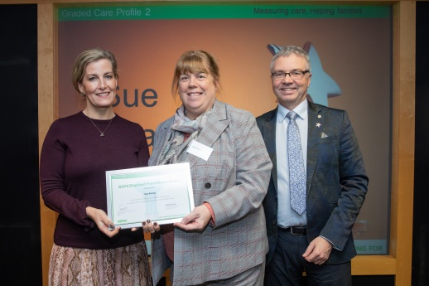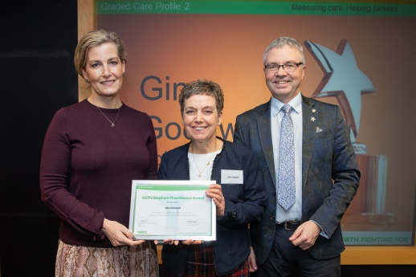

Sue and Gina contributed to a case study completed by the NSPCC and a video explaining how they use GCP2.

Caroline Westley and Dawn Hodson of the NSPCC, working jointly with an assigned team from Morgan Stanley developed a cost avoidance analysis tool. The diagram below shows the cost benefit analysis for Sue and Gina’s case:
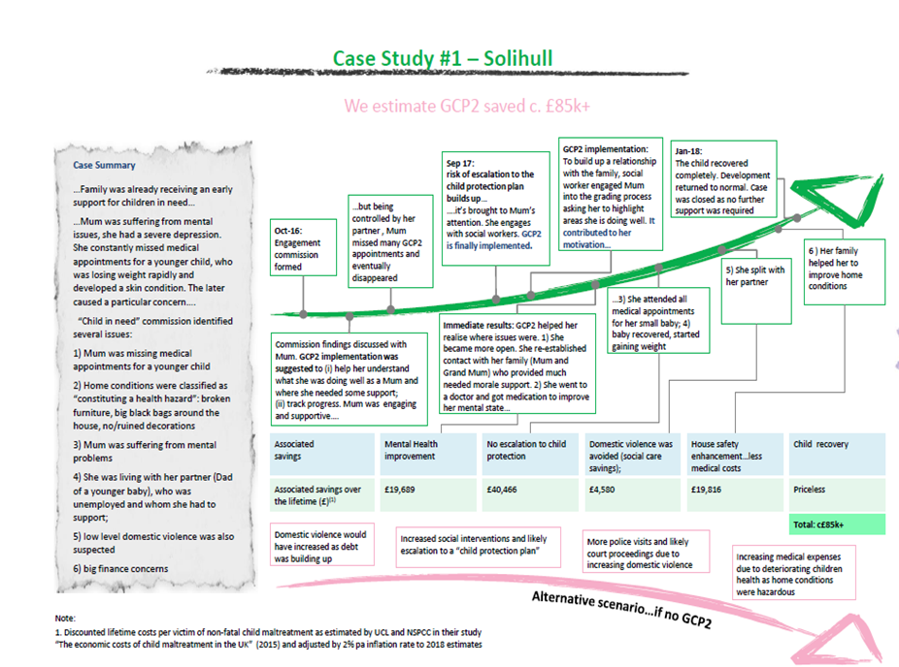

Module 6(d) - Substance misuse

Description: This module is delivered in partnership with Sarah Keeling from SIAS and focuses on families where substance misuse is suspected or has been disclosed. It covers awareness of the main types of substance abuse and the favoured substances prevalent in the Solihull borough. It aims to provide practitioners with an awareness of the impact of parental substance misuse, and the potential impact on children who misuse so that they can contribute to assessments where these issues are present.

Courses: 2
Attendees: 22
Completed pre-evaluation forms: 23
Completed post-evaluation forms (delegate): 15
Completed post-evaluation forms (manager): 4

Almost all delegates explicitly reported that they were more aware of the issue of substance abuse as a result of this course. They reported a better understanding of the various substances children/parents might use, and how different drugs are used in different ways. Trainees recognised that this variety of substance and use patterns can lead to a variety of different signs and indicators that a family or child may be experiencing problems with substances. They reported being more confident in identifying problems.

Evaluations also regularly mentioned that if a problem was identified, practitioners would know the next steps, including referral to specialist services and signposting of families. One delegate wrote that two families have been identified since she attended training.

A number of practitioners reflected that they had a better understanding of what life might be for a child whose parents misuse substances.

Module 7: Physical Abuse: Impact on child development

Description: Module 7 is delivered by Dr Alan Stanton- By completing this module attendees should be able to spot signs of physical abuse and understand its impact on a child’s development. Further to this, they should be able to effectively use evidence informed assessment tools and use contributions from partner agencies to inform assessment.

Courses: 1
Attendees: 7
Completed pre-evaluation forms: 7
Completed post-evaluation forms (delegate): 5
Completed post-evaluation forms (manager): 2

Evaluations of this course indicated that delegates left with a greater awareness of the signs of physical abuse. In particular two delegates mentioned that they were more able to identify suspicious injuries; one practitioner wrote: ‘[The module] helped [me] to identify different types of injuries and how they could be sustained did not match families account of injuries - this has since resulted in child protection case for the children’.

Another common theme was the practitioners stating that the module gave them the confidence to ask difficult questions to parents when physical abuse was suspected.

Finally, evaluations mentioned that they now had a better understanding of the short and long term impact of abuse of children – further motivating them to identify and deal with abuse as early as possible.

Module 8: Emotional Abuse: Impact on child development

Description: By completing Module 8, attendees should be able to spot signs of emotional abuse and understand its impact on a child’s development. Further to this, they should be able to effectively use evidence informed assessment tools and use contributions from partner agencies to inform assessment

Courses: 2
Attendees: 21
Completed pre-evaluation forms: 23
Completed post-evaluation forms (delegate): 5
Completed post-evaluation forms (manager): 1

Overall, practitioners spoke about having an increased understanding of, and ability to spot, emotional abuse in its different forms. They also reported increased confidence in addressing these issues once identified. Practitioners stated they now felt better equipped to support both the child and the family, after attending the course. One practitioner wrote: ‘In my work with parents, I am able to structure conversations better where I feel that home influences are impacting upon a child's well-being. I am much more aware of emotional abuse and signs to look for in a school environment.’
The evaluation forms also revealed that knowledge from the training has since been disseminated throughout various organisations and practitioners are more aware of the importance of communicating concerns about children.
Module 9: Sexual abuse: Impact on child development
Description: After completing this course delegates should be able to spot signs of sexual abuse and understand its impact on a child’s development. Further to this, they should be able to effectively use evidence informed assessment tools and use contributions from partner agencies to inform assessment

Courses: 1
Attendees: 5
Completed pre-evaluation forms: 7
Completed post-evaluation forms (delegate): 3
Completed post-evaluation forms (manager): 2

In evaluations, participants often spoke about their increased knowledge surrounding the signs and symptoms of sexual abuse. As a result they reported feeling more confident when applying this to real life situations and raising any concerns they may have. One delegate specific mentioned using the CSE ‘Petch’ tool to help evaluate the risk in a case.

Overall, practitioners felt that this course was particularly useful in helping them have difficult conversations with children who they suspect are victims of abuse.

Managing Allegations against Staff (MAAS)
Description: This training is delivered by SMBC- Hillary Hargrave and Deana Leonard from HRE and Simons Stubbs, Emma Lightfoot & Anna Stephens LADO Service- on behalf of the LSCB. It is for those with supervisory responsibilities for staff undertaking safeguarding work; managers and strategic leads in multi-agency organisations. This workshop provides an essential grounding for managers to enable them to manage allegations of abuse against staff who:
• Have, or may have harmed a child
• Have, or may have committed a criminal offence against or related to a child/ren
• Have behaved towards child/children in a way that indicates s/he is unsuitable to work with children

Courses: 3
Attendees: 33
Completed pre-evaluation forms: 37
Completed post-evaluation forms (delegate): 11
Completed post-evaluation forms (manager): 9

Following the courses many delegates reported that it had made them more confident in knowing what to do should an allegation be made. One delegate specifically mentioned a better understanding of when the police need to be informed.
A common theme in the evaluation forms is that practitioners felt they would be better placed to advise colleagues within their organisations should an allegation be made. In particular learning they could contact LADO for advice was particularly useful for some.
Participants also stated that the course was a good opportunity to discuss the topic with other delegates who might have more experience with these issues.
Module-by-Module Attendance Overview
In terms of year by year changes to module attendance, there are two main modules to note – Module 2 and Module 6 and seen in the figure below.

The graph shows a few things of note. Firstly, the 2017-2018 financial year saw exceptional attendance at Modules 2 and 6c. Attendance in that year jumped up from the previous year, and has not been sustained this year. The Local Authority Education Advisory Service recommend that new Designated Safeguarding Leads (DSL) need to attend Module 2, so if there are new appointments to DSL posts, then numbers will increase for Module 2. While it is disappointing that this growth of those accessing Module 6c GCP2 has not been maintained, this may be because those in a position to use the tool have now all been trained and the focus now needs to move from training on the tool, to embedding its use in practice.
Modules 6 has seen a drastic drop in attendance. In the 16-17 and 17-18 financial years saw attendance of between 110 and 120 delegates for this module. In 18-19 a total of just 42 delegates attended. That is around a 60% drop. Part of this can be explained by the fact that people wishing to complete Module 6c needed to have completed Module 6 beforehand, however Neglect is a priority area for the board and even those practitioners who do not wish to use GCP2 would benefit from an in depth understanding of Neglect and its impact on child development.
Modules 5A, 7, and MAAS also saw a drop as compared to the previous two years. This is not as drastic as the change in module 6 however, and would be expected given the general drop in attendees described at the beginning of this report.

Multi-agency Training Pool
The LSCB could not develop and deliver such highly valued training without the contributions and support from many agencies and individuals. In addition to the agencies and individuals mentioned above, the LSCB would like to acknowledge the commitment and support provided by members of multi-agency training pool who contribute to development and support delivery of a wide range of courses:

Ceri-Lisa Murland -National Probation Service
Deborah Adams -SMBC Social Care
Francesca Crossfield - WMP
Gina Godwin -Wise Owls Nursery
Nicky Thomas –HoEFT/UHB Community Services
Rebecca Brown – SMBC Social Care
Toni Clifton -SMBC Social Care

LSCB & SSAB Learning Faculty (Now known as ‘Learning and Development Forum)
The purpose of the faculty/forum is to provide an open consultative forum to enable multi-agency practitioners and managers who access LSCB/SSAB training programmes to review previous training, monitor existing training and engage in the planning and design of future training provision in order to meet front-line needs as well as national and local drivers including legislation, policy and practice development. The faculty/forum is an opportunity for practitioners to influence training.
There were 3 meetings during the 2018-19 financial year: May 2018, which featured a discussion on exploitation, September 2018, which discussed mental health and wellbeing, and January 2019, which included a presentation on Deprivation of Liberty and Mental Capacity.
The notes and further information about the learning faculty can be found on the LSCB website http://www.solihulllscb.co.uk/training.php

Conclusions
The purpose of LSCB training is not only to increase knowledge and confidence, but to challenge practitioners thinking and allow them to do this in a multi-agency environment. Both the quantitative and qualitative data from evaluations demonstrate that these goals are being met. However, while each module continues to have this positive impact, in the 2018-19 financial year 25% less delegates benefited from the training than have on average in the past. This drop might be partly be explained by large commissioning/structural changes in some sectors. Nonetheless, this attendance is disappointing, as attendees who where able to attend training and took part in the evaluation process regularly reported that the training has given them confidence. This was confidence in there own knowledge, confidence that they could act if a situation presented itself, and confidence to challenge practitioners in single and multi-agency meetings.
Delegates also felt that the knowledge they had gained in the various assessment tools, types of abuse and signs and indicators of that abuse had armed them with the ability to spot, assess and act upon worries with the children they work with. In terms of this action, a great number of practitioners left training with a better understanding of the LSCB thresholds, who to refer to and what to include in referrals. This action was not limited to theory either; there are numerous cases of delegates telling us about specific action with children, inspired by something they learnt on a course.
Communication is a key factor in safeguarding children and, again, delegates benefitted both from the contents of the courses and the opportunities to work and network with participants from other agencies.
Finally, managers who have responded reported improved confidence and awareness of issues from staff members who had attended and often reported learning had been disseminated amongst other staff through the attendee.
Nevertheless, the low number of attendees ultimately means that this impact is being felt by fewer practitioners and in turn, fewer children.

Training: Next steps
From the 1st May 2019 the LSCB will cease to exist and the new Local Safeguarding Children Partnership will come into existence;
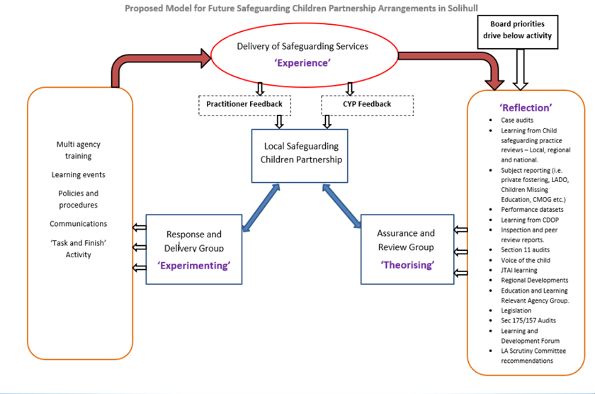
Through the Safeguarding Partnership, the Assurance and Review Group will inform what needs to be considered within the multi-agency training strategy which will be designed and delivered through the Response and Delivery Group.
There is commitment for the current delivery of training Modules to continue; however it is envisaged that there will need to be an increase in recruitment to the Multi-Agency Training Pool to support delivery the Early Help Module 1 with the introduction of a new multi-agency early help assessment.
There will also be changes to those courses provided in Module 5 as the LSCP continues to work with the Solihull Safeguarding Adults Board (SSAB) and The Safer Solihull Partnership (SSP) to form a collaborative Exploitation Reduction Group. The group is to focus on wider exploitation, incorporating contextual safeguarding, sexual & criminal exploitation, modern slavery, and trafficking. New training will reflect these changes.
In addition to the Modules there will be some reflection sessions planned around learning from serious case reviews or case learning reviews. These will be free of charge and will take place in 2 hour late afternoon sessions. They will be facilitated in a style that compliments the suggested agenda for a case learning meeting; to promote the use of this mechanism for reviewing multi-agency work in practice; highlighted as a need in the recent case audit cycle.
The Learning Faculty ran in partnership with SSAB was reviewed in January as attendance numbers have dwindled; although those who regularly attend reporting that they find it a very useful forum. Its name has been changed to the Learning and Development Forum, as attendees felt Learning Faculty may have been putting some people off attending; dates are set for a further 3 meetings through the next financial year and this will be reviewed again in January 2020.
All multi-agency training provided is advertised and booked via the website: https://www.solihulllscp.co.uk/training.php In addition to this regular updates are provided in every LSCB/P newsletter. The LSCB multi-agency safeguarding workforce development strategy introduced as a general guide, that all those who regularly make child protection referrals, are regularly expected to attend child protection conferences and core groups, and/or manage or supervise those who do, should receive a minimum of 3- 6hours of multi-agency training; ideally at least 1 module per year; this is in addition to any single agency training; therefore partners will either need to take appropriate actions to ensure this attendance happens, or this guidance will need to be reconsidered when the strategy is revised.

 | SMBC |  |  |  | HEALTH
 | SMBC Adult Social Care | SMBC Childrens Social Care | SMBC Engage services | SMBC Other Staff inc. Elected Members | UHB Acute Services | UHB Community Services | South Warwickshire NHS FT | NHS Birmingham and Solihull CCCG | BSMHFT | West Midlands Police | National Probation Service | SWM Community Rehabilitation Company | Solihull Community Housing | Schools & Colleges | Early Years (non maintained) | CAFCASS | UK Visas & Immigration | Voluntary/Third Sector | Others (e.g. Private business/out-of-borough organisations) | Total
Managing Allegations against Staff (3 courses) | 0 | 0 | 0 | 2 | 0 | 0 | 1 | 0 | 0 | 0 | 0 | 0 | 0 | 26 | 3 | 0 | 0 | 1 | 0 | 33
Module 2 - Child Protection: An introduction to multi-agency working (7 courses) | 0 | 12 | 0 | 3 | 1 | 0 | 0 | 0 | 0 | 0 | 5 | 0 | 0 | 78 | 7 | 0 | 0 | 13 | 6 | 125
Module 3 - Child Protection: The challenges of multi-agency working (3 Courses) | 0 | 3 | 1 | 0 | 0 | 0 | 4 | 0 | 0 | 0 | 0 | 0 | 0 | 18 | 3 | 0 | 0 | 5 | 3 | 37
Module 4 - Child Protection: Analysis, judgement and leadership in partnership working (2 courses) | 0 | 0 | 1 | 1 | 0 | 1 | 1 | 0 | 0 | 0 | 0 | 0 | 0 | 14 | 0 | 0 | 0 | 0 | 0 | 18
Module 5A - Child Sexual Exploitation Awareness (5 courses) | 0 | 32 | 4 | 4 | 0 | 2 | 0 | 0 | 0 | 0 | 1 | 0 | 0 | 15 | 0 | 0 | 0 | 6 | 2 | 66
Module 5B - CSE: skills for working with vulnerable children & young people (2 courses) | 0 | 13 | 4 | 0 | 0 | 0 | 0 | 0 | 0 | 0 | 0 | 0 | 0 | 5 | 0 | 0 | 0 | 4 | 1 | 27
Module 6 - Neglect: Impact on child development (5 courses) | 0 | 9 | 3 | 0 | 0 | 2 | 3 | 0 | 2 | 0 | 2 | 0 | 0 | 17 | 0 | 0 | 0 | 4 | 0 | 42
Module 6(b) Neglect: Domestic Abuse (2 courses) | 0 | 0 | 0 | 0 | 0 | 0 | 6 | 0 | 0 | 0 | 0 | 1 | 0 | 12 | 1 | 0 | 0 | 2 | 0 | 22
Module 6(c) Neglect: The Graded Care Profile 2 (4 courses) | 0 | 28 | 7 | 0 | 0 | 0 | 1 | 0 | 0 | 0 | 0 | 0 | 0 | 1 | 0 | 0 | 0 | 1 | 0 | 38
Module 6 (d) Neglect- Substance misuse (2 courses) | 0 | 1 | 3 | 0 | 0 | 0 | 0 | 0 | 0 | 0 | 0 | 0 | 0 | 11 | 4 | 0 | 0 | 2 | 1 | 22
Module 7 - Physical Abuse: Impact on child development (1 course) | 0 | 0 | 2 | 1 | 0 | 1 | 0 | 0 | 0 | 0 | 0 | 0 | 0 | 3 | 0 | 0 | 0 | 0 | 0 | 7
Module 8 - Emotional Abuse: Impact on child development (2 courses) | 0 | 0 | 2 | 0 | 0 | 0 | 6 | 0 | 0 | 0 | 0 | 0 | 0 | 7 | 3 | 0 | 0 | 2 | 1 | 21
Module 9 - Sexual Abuse: Impact on child development (2 courses) | 0 | 0 | 2 | 0 | 0 | 0 | 0 | 0 | 0 | 0 | 0 | 0 | 0 | 2 | 0 | 0 | 0 | 1 | 0 | 5
Total | 0 | 98 | 29 | 11 | 1 | 6 | 22 | 0 | 2 | 0 | 8 | 1 | 0 | 209 | 21 | 0 | 0 | 41 | 14 | 463

