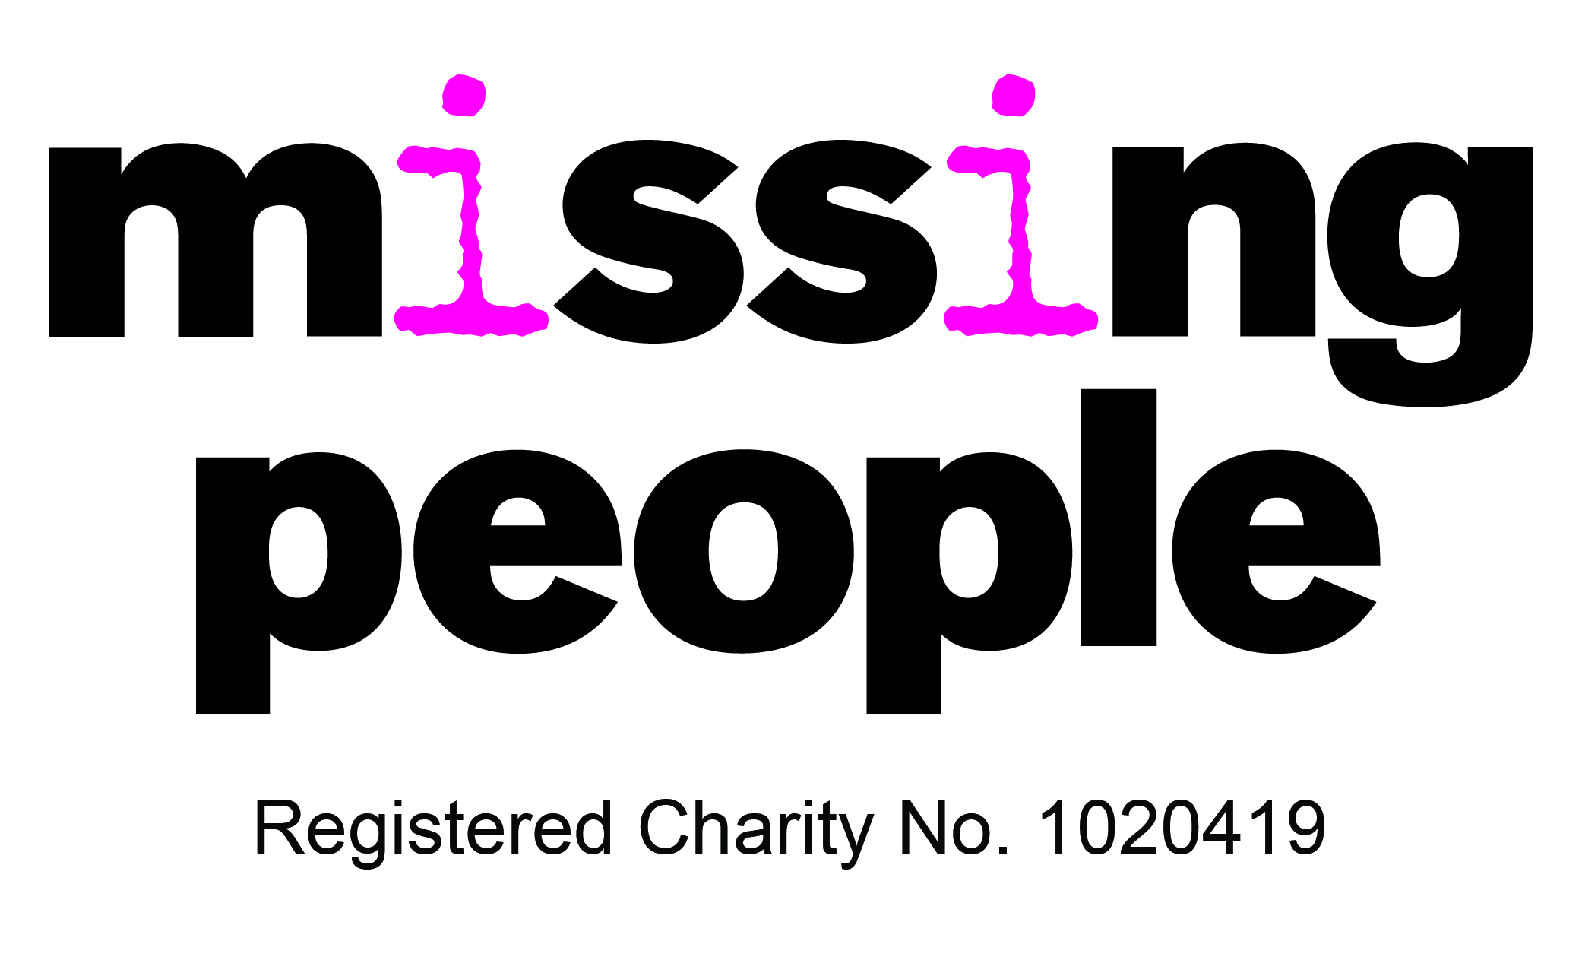
Briefing for parents; June 2015
‘Say Something’: New service for young people to report sexual exploitation
Go-live date: 1st July 2015

Purpose of briefing
To inform you of a new national service which will seek to raise awareness amongst young people of the risks and dangers of CSE and provide advice on how to keep safe and where to seek support. The new service will provide young people with a means of reporting CSE through a free, 24/7, anonymous helpline provided by Missing People.
This service will not replace existing local services or existing helpline or service provision, but may generate additional information about exploitation in your area.

The service
The charity Missing People is working in partnership with the NWG Network Tackling Child Sexual Exploitation to provide an awareness campaign and national Freephone reporting service, funded by the Department for Education (DfE). The service will go live on 1st July 2015.
The service will offer a complimentary and unique additional service, through an anonymous reporting mechanism for young people alongside balancing support and safeguarding them. The helpline will also look to signpost and/or refer young people to relevant local services.
Missing People will send disclosed information about child sexual exploitation to relevant statutory agencies and will expect an appropriate local safeguarding response. The charity will also help the person reporting to be safe, and access support where needed.
Parents can share the Say Something helpline with other parents and young people who aren’t able to be fully open up about what is happening, so the young people can report their worries anonymously.
Missing People also operates the Runaway Helpline and has 20 years’ experience supporting missing and exploited young people and their families.

‘Say Something’ helpline:
Call or Text 116000
Website www.stop-cse.org/saysomething
For enquiries email: bina@nwgnetwork.org
What can you do?

- Help with promotion of the campaign on social media and also directly give the helpline to young people who may need it

Find us on:
Facebook: /SaySomething
Twitter: @SaySomethingIf
Web: www.stop-cse.org/saysomething

