

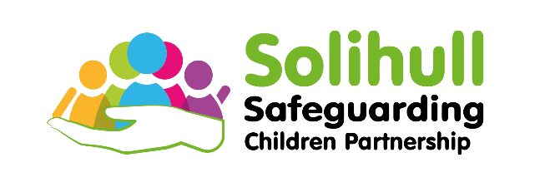

Child Safeguarding Practice Reviews

Information for families

The Independent Lead Reviewer for your case is:

If you have any questions or want to know more contact:

Solihull Safeguarding Children Partnership

[sscp@solihull.gov.uk](mailto:sscp@solihull.gov.uk)

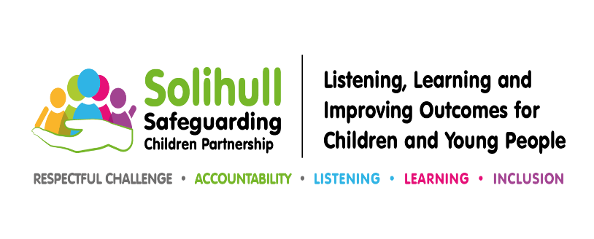

What is a Child Safeguarding Practice Review?

The Police, Health, Council, and other agencies are required to work together to keep children safe. When things go wrong (such as when a child or young person has been seriously harmed or has died as a result of possible abuse or neglect) they are required to take action to prevent similar death or injuries happening in the future.

To do this they usually undertake a Child Safeguarding Practice Review. This examines how organisations worked together to provide services to the child or young person who is the focus of the review, and to their family.

The purpose of the review is to:

* establish whether there are any lessons that can be learned by professionals and organisations;
* identify who those lessons are for; and
* plan how the lessons will be acted upon.

A Child Safeguarding Practice Review is not an investigation into how a child died or was seriously harmed. It is also completely separate from any investigation by the Police or the Coroner.

Whilst we recognise your grief and anxiety, we believe that the circumstances relating to your child mean that a Child Safeguarding Practice Review should be carried out.

Who will carry out the Child Safeguarding Practice Review?

An independent Lead Reviewer has been appointed to oversee the review and

produce a report that will be published. The Lead Reviewer will be supported by senior managers from organisations such as health, police, and the Council.

All the organisations who have worked with your child or family will be asked to provide information. Analysis of this information will be included in the final report.

Practitioners and managers involved in the case will also be invited to a meeting to share information and help identify how to improve services and support for children and

families in the future.

How are parents and families involved?

We are aware that this is a very difficult time for you, but we want to learn all we can for the future.

We believe it is very important that family members share their experience of services and tell us whether anything could have been done better. You are, therefore, invited to meet the Lead Reviewer to discuss any concerns you have about the services you received and to share any things that you feel helped you or your family.

When the review is complete, the Lead Reviewer will arrange to meet with you to share the key learning and to provide you with a copy of the final report.

If you want to know about any changes that come from the review, you should talk to the Lead Reviewer about how you can hear about these and who can keep you informed of progress.

How long will the review take?

All Child Safeguarding Practice Reviews should normally be completed within six months of the decision being taken to start the review. Sometimes this timescale needs to be extended.

Publication of the report

The report will not contain any identifying details of your child or family. It will then be published on the internet.

The report will be available to all

professionals to ensure that the lessons learned, and recommendations made are put into practice.